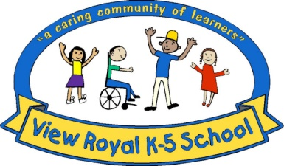

**View Royal**

Elementary School

218 Helmcken Rd., Victoria, B.C. V9B 1S6

Ph: 250-479-1671 Fax: 250-744-2389

**Fall Cross Country Season (Grade 3, 4 and 5) MC900078715[1]**

Dear Parents,

Welcome to Fall Cross Country. **Cross Country practices start on Thursday**! The first meet will be **Monday the 1st of October at Clover Point**. This sport is organized for elementary students in our school district and designed to train students to run in Cross Country races that are approximately 1.2 km in distance. There will be four Cross Country Meets this season, as follows:

**3:45 pm Monday October 1st Clover Point**

**3:45 pm Tuesday, October 9th Gorge Kinsmen**

**3:45 pm Monday, October 15th Topaz**

**1:00 pm Monday, October 22nd City Finals at Beacon Hill Park *arrive by 12:30\***

There are separate categories for boys and girls at the Meets, in Grades 3, 4 and 5. We will practice at school two times per week, and students will need shorts and running shoes for these practices. Practices this year will include practice runs on sidewalks in the neighbourhood off the school grounds under my supervision. **Parent helpers who can run with us would be much appreciated!**

**Practice Times**

**Practices start: Thursday, September 20th**

**Tuesdays 8:10 am – 8:40 am (before school)**

**Thursdays 8:10 am – 8:40 am (before school)**

For your child to participate in cross country this season please go our school website, under Programs & Clubs Tab from top menu then click on Athletics and then finally Cross Country. This will take you to an on-line sign up form.

Parents will need to be able to drive your child to the above meets, or arrange for a ride with another family on that day. Thank you for your support!

Karen Higginbotham

Coach