December 21, 2018
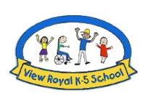
VIEW ROYAL ELEMENTARY NEWSLETTER
218 Helmcken Road, Victoria BC V9B 1S6 Ph: 250-479-1671 Fax: 250-744-2389
E-Mail: viewroyal@sd61.bc.ca Web Site: http://www.sd61.bc.ca

IMPORTANT DATES TO NOTE:
Friday, December 21st | LAST DAY OF CLASSES BEFORE WINTER BREAK
Monday, January 7th | SCHOOL BACK IN SESSION. Welcome back!
Friday, January 11th | Fun Food Orders Due – 3:00pm
Tuesday, January 15th | DARE Program (grade 5 students)
PRINCIPAL’S ADDRESS:

Inspired by the lyrics sung so sweetly by the students...

Bring a jolly, jazzy Christmas to me.
Take the time to celebrate, The ones that you appreciate, The people in your life that make you grow.
Oh Mister Santa Claus, You’re still a hero, my one and only hero to me.
This is my winter song to you. Don’t make me spend Christmas time alone.
Just make yourself at home, Come on in you’re not alone.
This is my winter song to you. The storm is coming soon, it rolls from the sea My voice; a beacon in the night, My words will be your light.
Stand beside your brothers and your sisters and the others and light a fire inside and let it show
Have a sunny Christmas, Gather everyone you know. Have a sunny Christmas, Take it everywhere you go.

Thank you students for entertaining us and bringing the true spirit of the season. Thank you Mr. Lee, our music teacher and multi-instrumentalist, for putting together a varied and incredibly exciting evening. Thank you, office staff, custodial staff and the PAC for the behind the scenes support. Thank you to our teachers for if it wasn’t for their supervising, these evening events would not happen.

The Senior’s Tea is a special tradition at this school. Thank you grandparents who travelled near and far. I also appreciated the stories from the students who invited their adopted grandparents: folks who live on their street, their landlords, or family friends. We love all grandparents!

We would like to welcome a familiar face, Mrs. Anne Downton, a new EAG to our school.

We wish Reese the very best as they head to a new adventure as an EAG for Strawberry Vale School. Reese has been a dedicated EAG and our Rainbow Club leader for five years at View Royal. Thank you Reese for all you’ve done to support our students and our staff. Lindsay Henderson, an EAG has moved to Mount Doug Secondary. Best Wishes at your new school, Lindsay. You will be missed. Lastly, we’d like to say thank you and wish Leanne Felton all the best as she continues her work within the district.

Happy Holidays from all of us at View Royal School. See you on Monday, January 7th, 2019! Happy New Year!

~Miss. Pick

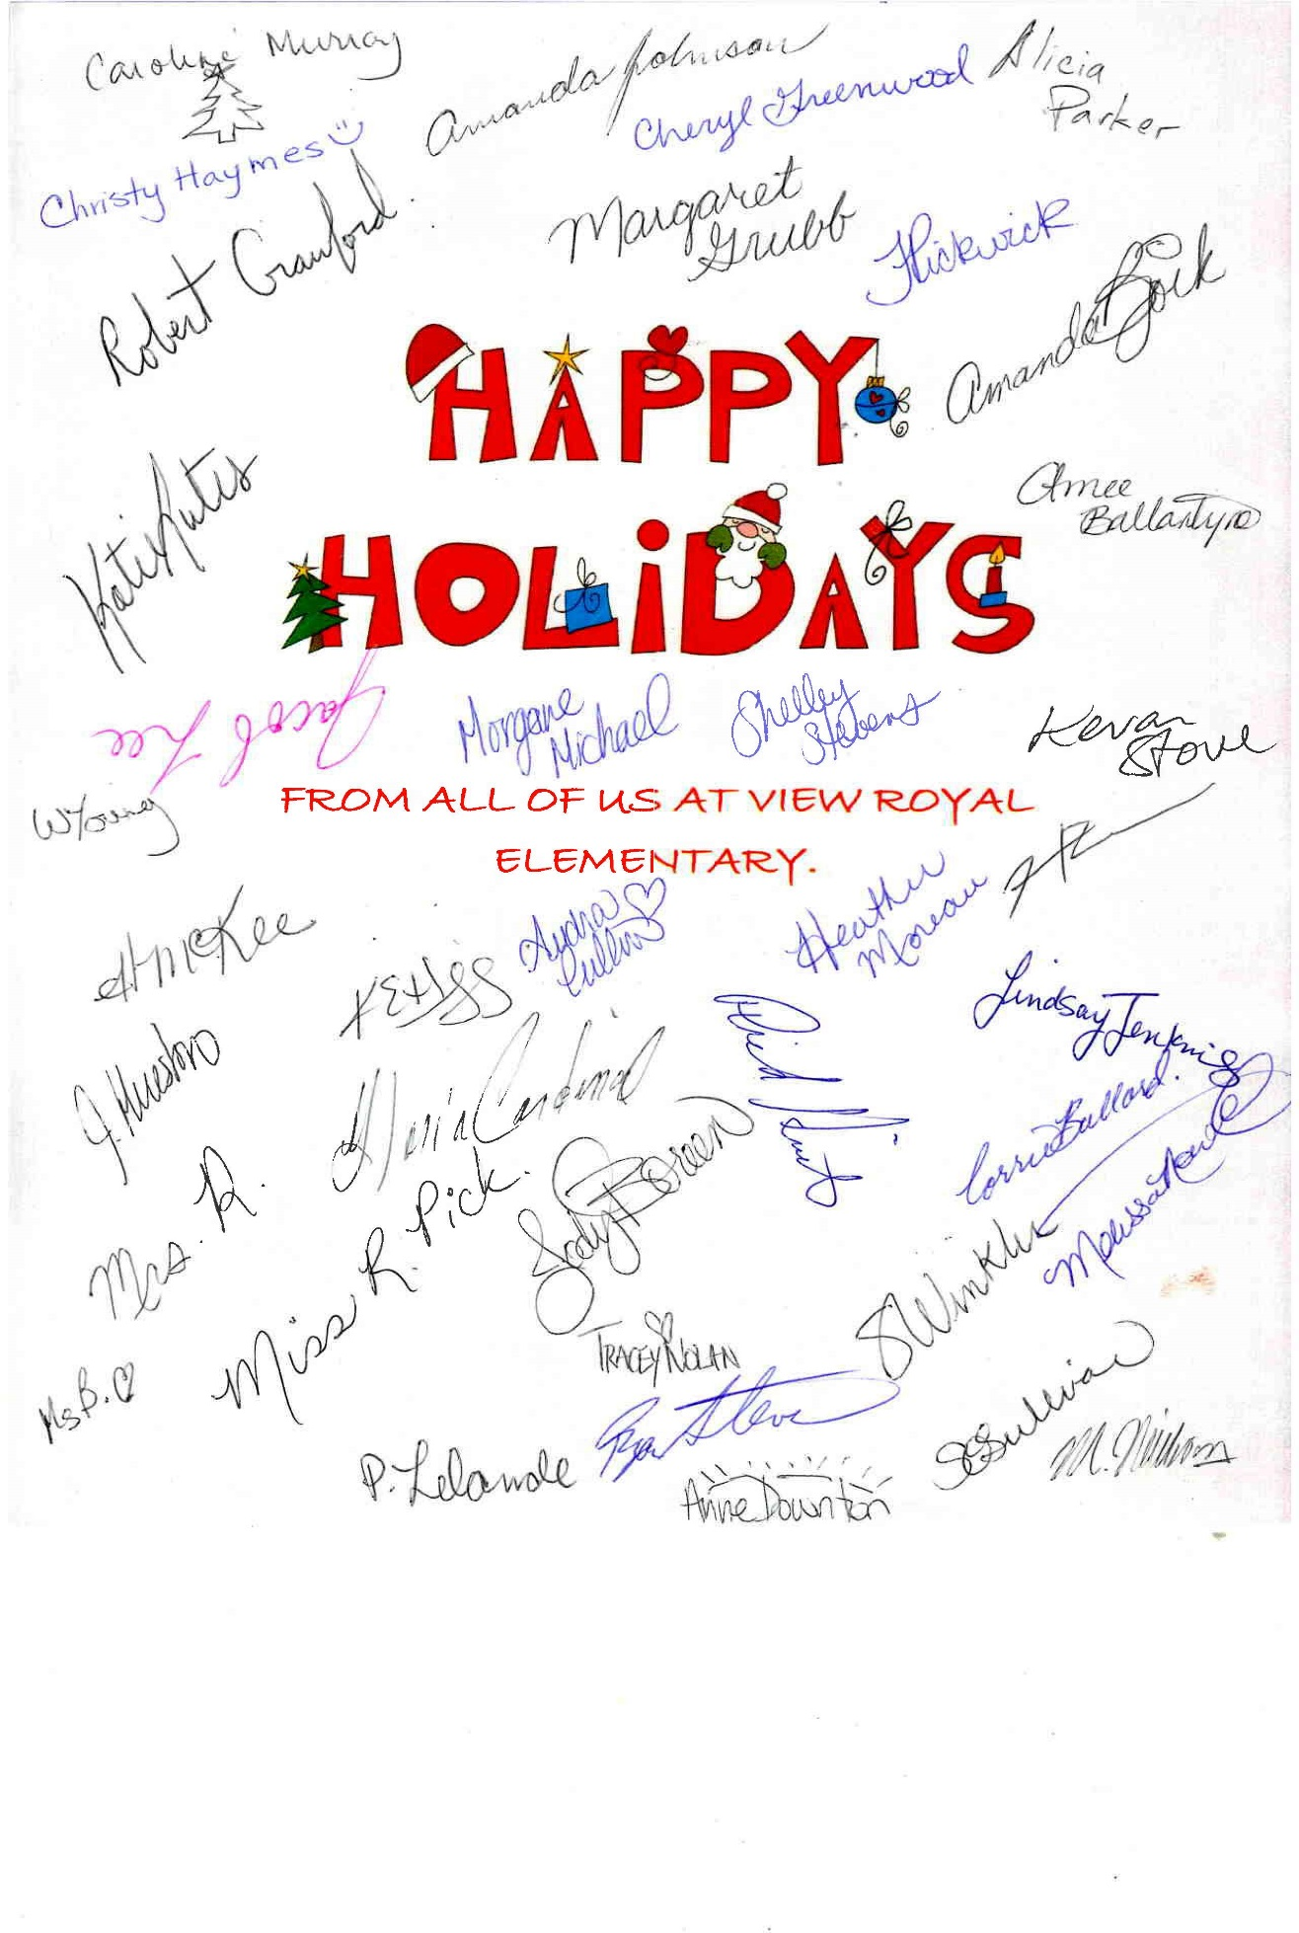

End of the Year Numbers:

Excited Children: 313
Classrooms: 17
Staff: 50
Sock Hamper for the Homeless: 121
Christmas Concert Tickets over two nights: 700
Number of people turned away: 0
Seniors at the Tea: 150
Number of Parents who washed 150 tea cups: 6

*************************************************************************************
SOCK HAMPER SUCCESS!
Thank you to everyone who donated items to our Sock Hamper event. We were able to provide 121 socks filled with useful items to those less fortunate! We also donated 5 extra boxes of miscellaneous items to help the homeless population in Victoria.
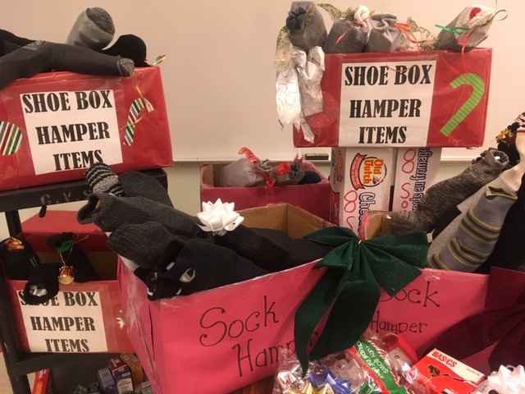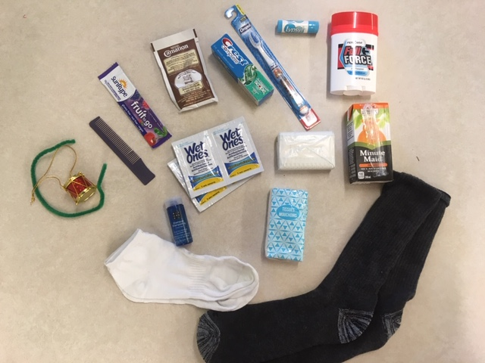

*************************************************************************************
Free Reading Website
If you are looking for more books to read with your children at home, Unite For Literacy is a FREE website developed by UBC that has online emergent and beginner level books. They are written in English and can be narrated in 41 different languages for dual language input. Some books are dual print for English and Spanish. https://www.uniteforliteracy.com
*************************************************************************************
Clothing Needed
Mud puddles are upon us and our supply of extra clothing is quickly diminishing. If you have any boys’ pants, size 6 -12 that you would be willing to donate we would appreciate it.
*************************************************************************************
View Royal School Receives BC School Fruit and Vegetable Nutrition Program
We are the recipients of free fruit and vegetables and milk twice every month. A few students and Mrs. Winkler help to distribute to all the classes as well as Strong Start. We are grateful to be a part of this program. This month a summary report was sent on the impact of this program across BC. Please find here a few key pages of the report you may find interesting…
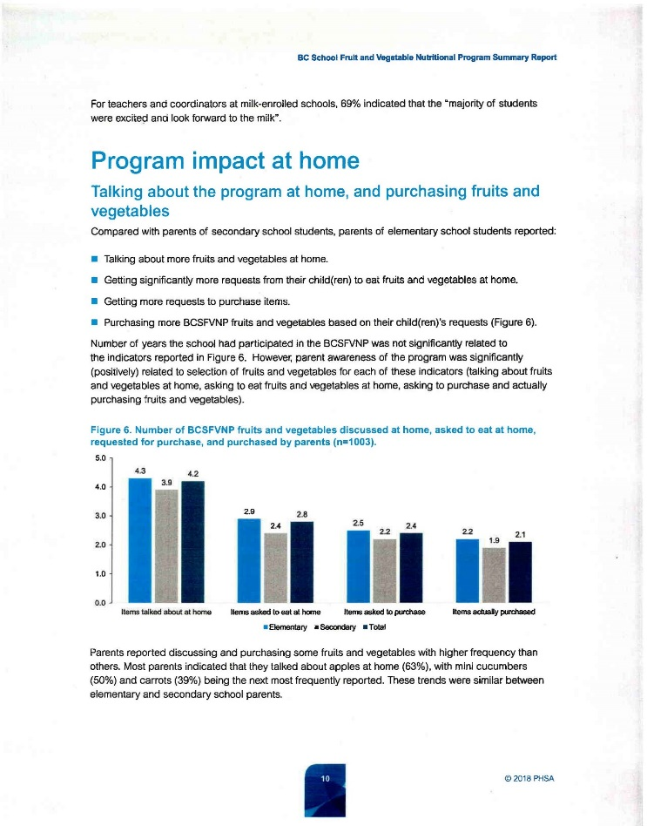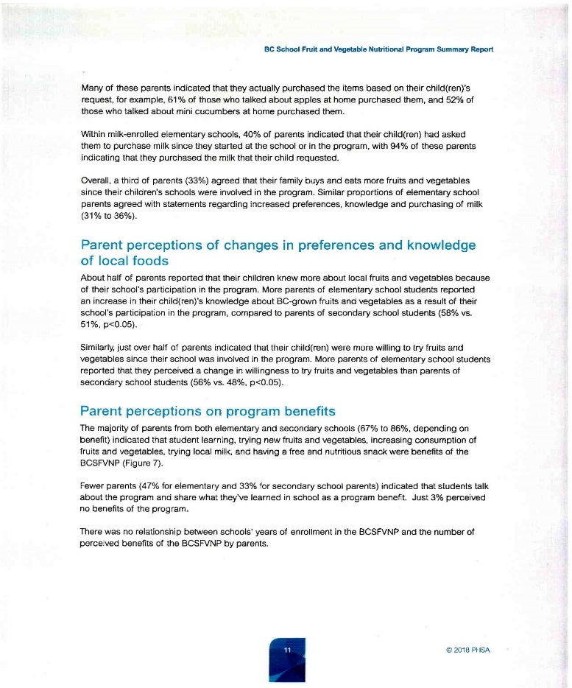
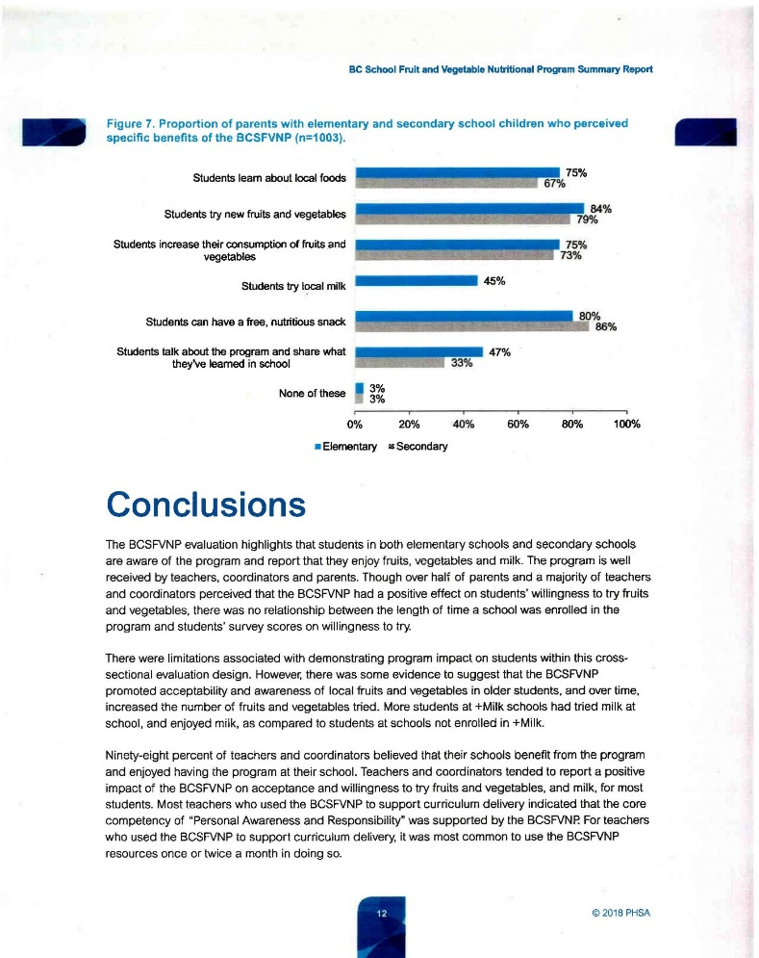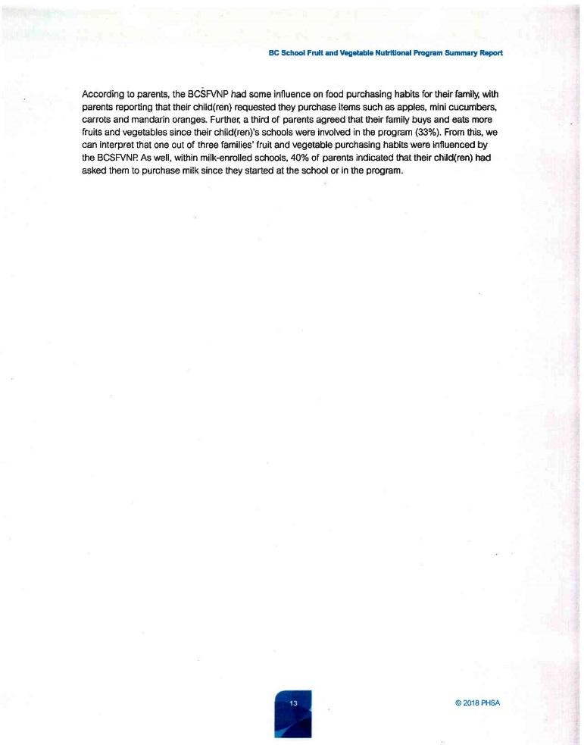

*************************************************************************************
SD61 Important Dates to Note
Registration & Transfers:
https://www.sd61.bc.ca/parent-student-resources/registration/registration-transfer-dates/
Late French Immersion Registration:
https://www.sd61.bc.ca/parent-student-resources/registration/late-french-immersion/

*************************************************************************************
PAC News!

Follow us on Facebook! www.facebook.com/viewroyalpac
Or visit our website www.vrpac.com
You will find up to date information about what your PAC is up to!

PAC is taking a break over December, so our next meeting will be on:
Wednesday, January 9th
6:30 pm
School Library
Everyone welcome, we would love to see some new faces!!
Free babysitting is provided by the PAC.
*For the safety of our children, the PAC is now providing 2 babysitters at each meeting.

We always look forward to having new members and volunteers. Come out to enjoy one of our fun events and see what volunteering with us is all about. Or join us for a PAC meeting in the school library 6:30 every second Wednesday of the month. For information about volunteering,
or PAC meetings please email president@vrpac.com

Did you know that the Pac supports many of the ”extras” that are provided to our children at School? Without a PAC our kids would miss out on activities such as: Field trips, dances, movie night, fun fair, wheelchair basketball, special performances, fun food days, gymnastics, parent information nights, camps and much more.

If you are able to help, or have questions about volunteering for any event please contact fundraising@vrpac.com for more info
**********************************************************
CAN YOU HELP? DONATIONS NEEDED
The PAC is looking for donations to use for future Seniors’ Tea events. If you happen to have any of the following items that you would be willing to donate, please contact seniorstea@outlook.com

~ Teacups with saucers
~ Sugar bowls
~ Hand knit dishcloths
*No chipped items please
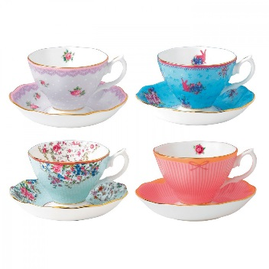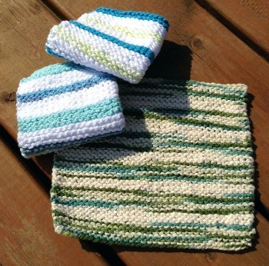

**********************************************************
*REMINDER* - Upcoming Bottle Drive Cancelled
Due to a shortage of volunteers at previous bottle drives, the PAC has decided to cancel the planned January drive. If you have bottles to donate at any time, please take them to the bottle depot and ask to have your refund donated to View Royal Elementary.

**********************************************************
ONGOING FUNDRAISING OPPORTUNITES!!!

Thrifty Foods Smile Cards
Thrifty Foods Smile Cards available through fundraising@vrpac.com
Pre-load your card at the store and 5% of your purchase is donated back to our school!
Cobs Bread at Eagle Creek Shopping Center
Cobbs Bread Eagle Creek- ask for your order to be put under View Royal Elementary *before being rung through* and 5% of your purchase will go back to our school!

Glenwood Meats - 1245 Parkdale Drive in Langford
Glenwood Meats is again offering 10% of all purchases back to our school!
Bring your receipts to the school drop box, or ask at Glenwood counter to have your receipt put into the View Royal box.
**********************************************************

Happy Holidays to all from View Royal School PAC!
Have a wonderful time with your family!

*************************************************************************
*************************************************************************

Westshore Basketball Camps

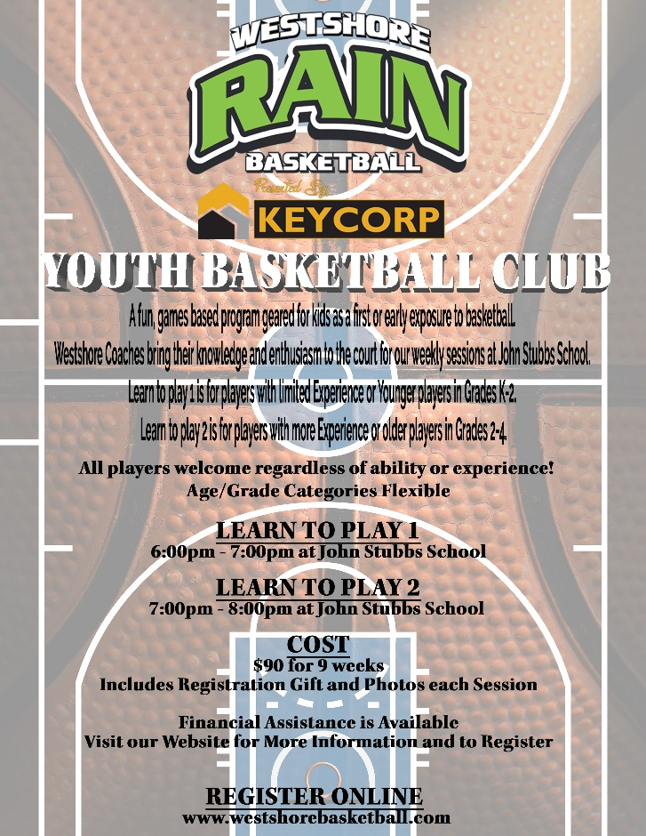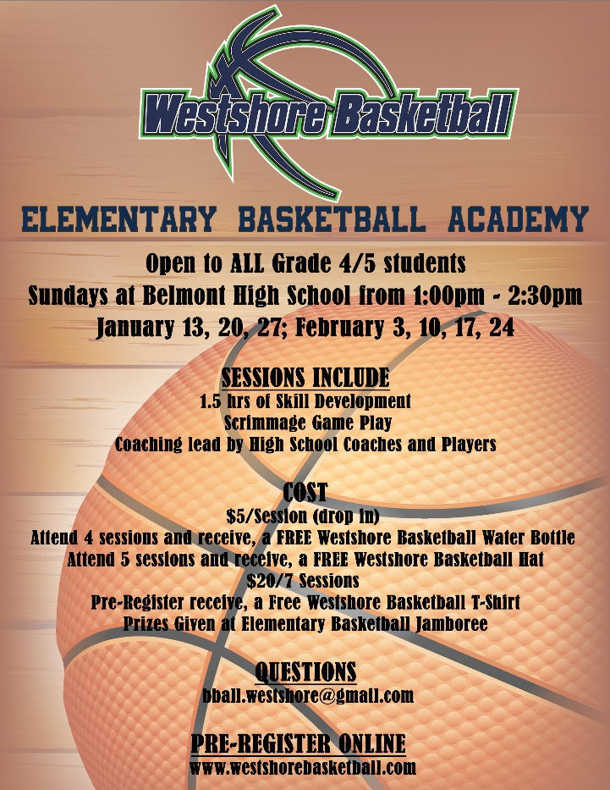
*************************************************************************

Free Female Box Lacrosse

The British Columbia Lacrosse Association (BCLA) are holding some FREE Female Box Lacrosse drop-in sessions and invite any girls to come and try it out.
They will have sticks and balls to use...all you need is to bring runners, a water bottle and if you can a helmet.
All players will also need to have a waiver signed by their parent which will be on hand at the events.
Girls born in 2007-2011
·Friday, January 4 (6:30-8:30pm) at Pearkes Fieldhouse Court #1 (3100 Tillicum Road – V9A 6T2)
·Tuesday, January 8 (6:00-7:30pm) at Pearkes Fieldhouse Court #1 (3100 Tillicum Road – V9A 6T2)
·Tuesday, February 12 (7:00-8:30pm) at Keating Elementary School (6843 Central Saanich Road – V8Z 5V4)
Girls born in 1998-2006
· Friday, January 4 (6:30-8:30pm) at Pearkes Fieldhouse Court #1 (3100 Tillicum Road – V9A 6T2)
· Thursday, January 10 (6:30-8:30pm) at Pearkes Fieldhouse Court #4 (3100 Tillicum Road – V9A 6T2)
·Tuesday, February 19 (7:00-8:30) at Keating Elementary School (6843 Central Saanich Road – V8Z 5V4)

If you have any questions please email fblacrosse@telus.net

